**Q 1 Write a program to find sum of all integers greater than 100 and less than 200 that are divisible by 7.**

**package** Day3;

//Q 1 Write a program to find sum of all integers greater than 100 and less than 200 that are divisible

//by 7.

**public** **class** Q1_Assignment2 {

**public** **static** **void** main(String[] args) {

**int** sum = 0;

**for** (**int** i = 100; i <= 200; i++)

{

**if** (i % 7 == 0)

{

sum = sum + i;

}

}

System.***out***.println("The Sum of the number between 100 to 200 which are divisible by 7 is: "+sum);

}

}

**  
  
  
Q 2 Write a program in java that ask three numbers from  
user and print the greatest among three .**

**package** Day3;

//Q 2 Write a program in java that ask three numbers from user and print the greatest among three .

**import** java.util.Scanner;

**public** **class** greaterAmongThree {

**public** **static** **void** main(String[] args) {

**int** a,b,c,d;

Scanner s=**new** Scanner(System.***in***);

System.***out***.println("enter three numbers ");

a=s.nextInt();

b=s.nextInt();

c=s.nextInt();

d = c > (a > b ? a : b) ? c : ((a > b) ? a : b);

System.***out***.println("greatest number is "+d);

s.close();

}

}

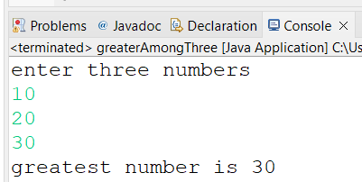

**3. WAP to find  ASCII value of a character .**

**package** Day1;

**public** **class** asciicode {

**public** **static** **void** main(String[] args) {

**char** u='a';

**char** v='A';

System.***out***.println((**int**)u);

System.***out***.println((**int**)v);

}

}

**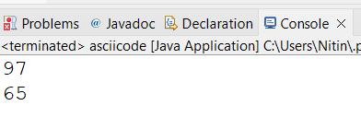  
  
  
4. Java Program to Check Whether an Alphabet is Vowel or Consonant**

**package** Day3;

**public** **class** Q4_Assignment2 {

**public** **static** **void** main(String[] args) {

**char** ch = 'b';

**if**(ch == 'a' || ch == 'e' || ch == 'i' || ch == 'o' || ch == 'u' )

System.***out***.println(ch + " is vowel");

**else**

System.***out***.println(ch + " is consonant");

}

}

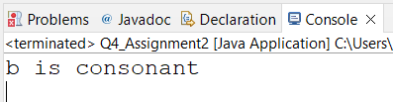

**5 Check if a Number is Positive or Negative using if else**

**package** Day3;

//Q5 Check if a Number is Positive or Negative using if else

**import** java.util.Scanner;

**public** **class** Q5_Assignment2 {

**public** **static** **void** main(String[] args) {

**int** a;

Scanner s=**new** Scanner(System.***in***);

System.***out***.println("enter a number ");

a=s.nextInt();

**if**(a>0)

System.***out***.println("positive");

**else**

System.***out***.println("negative");

s.close();

}

}

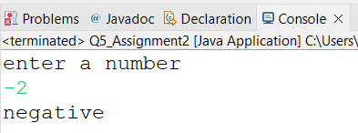

**6 WAP for swapping two numbers without using third variable**

**package** Day3;

**public** **class** SwappingWithoutUsing3rdVariable {

**public** **static** **void** main(String[] args) {

**int** x = 10;

**int** y = 5;

x = x + y;

y = x - y;

x = x - y;

System.***out***.println("After swapping:"+ " x = " + x + ", y = " + y);

}

}

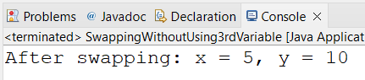

**7 Write a program that would print the information (name,  
year of joining, salary, address) of three employees by creating a class named  
'Employee'. The output should be as follows:  
  
  
Name           Year of joining        Address  
  
  
Ashish           1994    64C-WallsStreat                       
  
  
Sam                2000 68D-WallsStreat                        
  
  
John                1999   26B-WallsStreat                      
  
  
8 WAP to input basic salary of an employee and calculate its  
Gross salary according to following:  
  
  
Basic Salary <= 10000 : HRA = 20%, DA = 80%  
  
  
Basic Salary <= 20000 : HRA = 25%, DA = 90%  
  
  
Basic Salary > 20000 : HRA = 30%, DA = 95%**

**package** Day3;

**import** java.util.Scanner;

//8 WAP to input basic salary of an employee and calculate its

//Gross salary according to following:

//Basic Salary <= 10000 : HRA = 20%, DA = 80%

//Basic Salary <= 20000 : HRA = 25%, DA = 90%

//Basic Salary > 20000 : HRA = 30%, DA = 95%

**public** **class** Q8_Assignment {

**public** **static** **void** main(String[] args) {

**int** b;

**float** g;

Scanner s=**new** Scanner(System.***in***);

System.***out***.println("Enter the Basic Salary ");

b=s.nextInt();

**if**(b<=10000) {

g=b+b*(.25f)+b*(.9f);

System.***out***.println("Gross Salary is "+g);

}

**else** **if**(b<=20000) {

g=b+b*(.2f)+b*(.8f);

System.***out***.println("Gross Salary is "+g);

}

**else** {

g=b+b*(.3f)+b*(.95f);

System.***out***.println("Gross Salary is "+g);

}

s.close();

}

}

**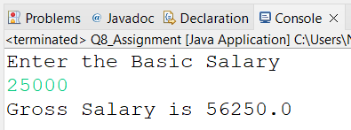  
  
  
Q  9 wap to print even numbers between 10 to 20**

**package** Day3;

//Q 9 wap to print even numbers between 10 to 20

**public** **class** evenNumbersBW10and20 {

**public** **static** **void** main(String[] args) {

**int** i;

**for**(i=10;i<=20;i++)

{

**if**(i%2==0)

System.***out***.println(i);

}

}

}

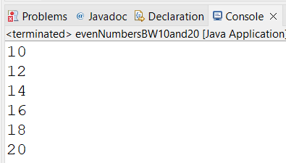

**Q 10 wap to check if a number is prime or not**

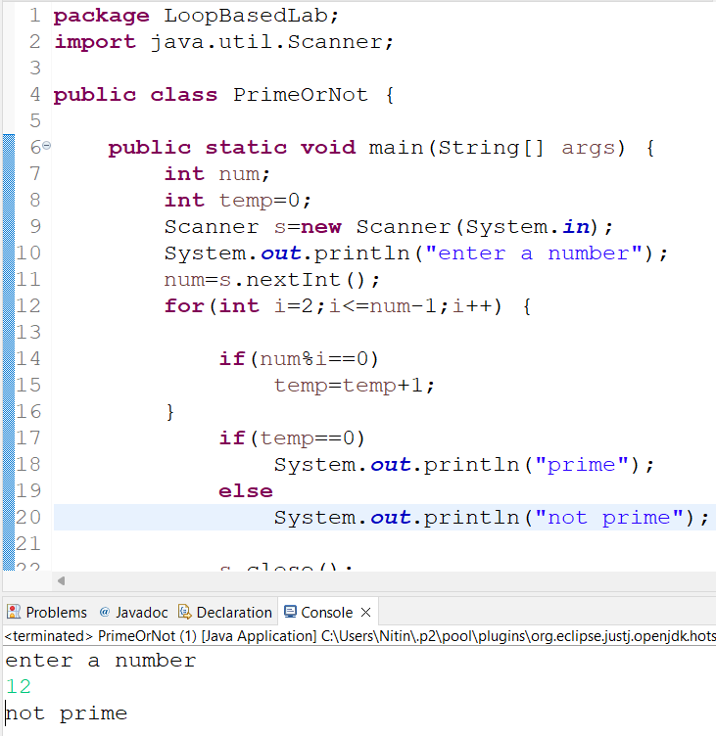

**Q 11 wap to reverse a given digit   123   321**

**package** Day4;

**public** **class** NumberReverse1 {

**public** **static** **void** main(String[] args) {

**int** n;

**for**(n=123;n!=0;) {

System.***out***.print(n%10);

n=n/10;

}

}

}

